Communication to a Database Proposed architecture for minimum functionality (Work in Progress):

1. Python Script on Raspberry Pi
2. AWS IoT Core
   1. Setup
      1. Prepare device

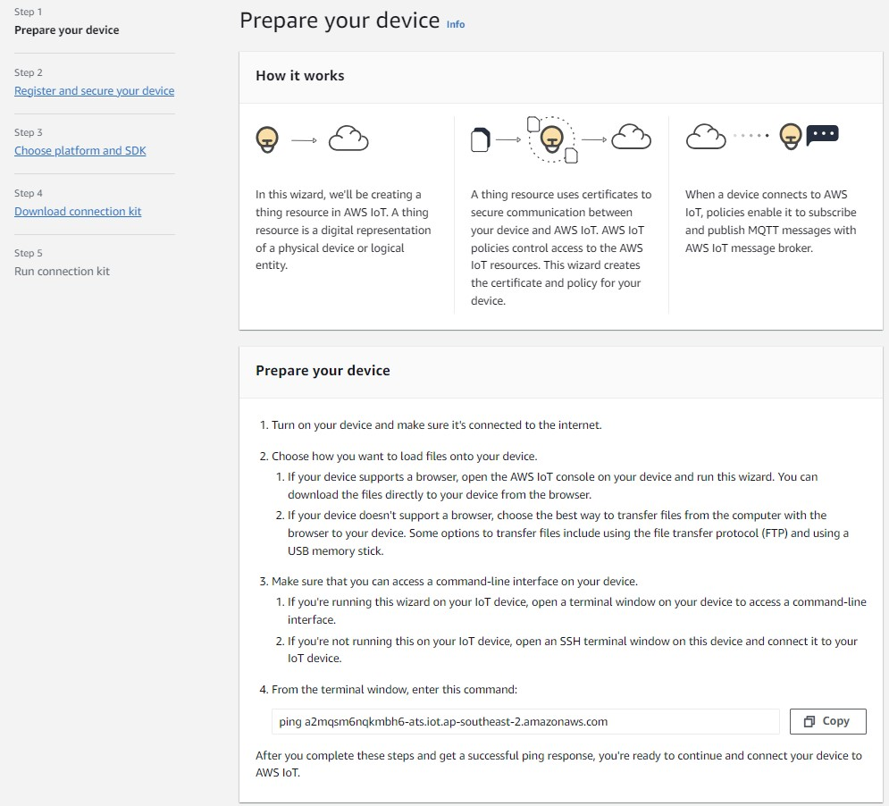

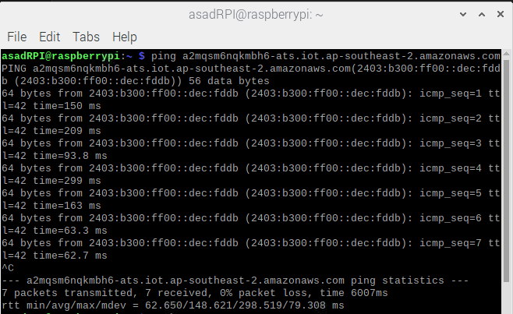

* + 1. Register and secure device

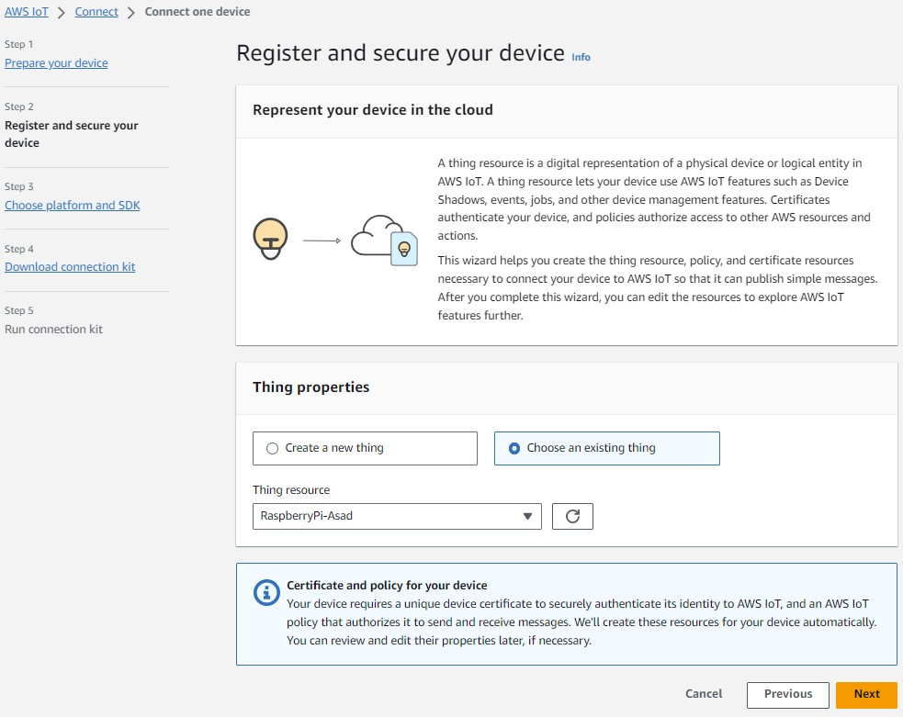

* + 1. Choose platform and SDK

* + 1. Download connection kit

* + 1. Run connection kit on device

1. MQTT Protocol for connection – need to determine MQTT 5 vs MQTT 3
2. AWS Lambda for function
3. AWS DynamoDB for Database
4. AWS Amplify Studio for building the WebApp
   1. Figma for design

Communication to Database Proposed architecture for maximum functionality (livestreaming video) Work in Progress:

1. Python Script on Raspberry Pi
2. AWS IoT Core - AWS Kinesis Video Streams for Video
3. AWS IoT Core
4. …. Not sure need to look into this